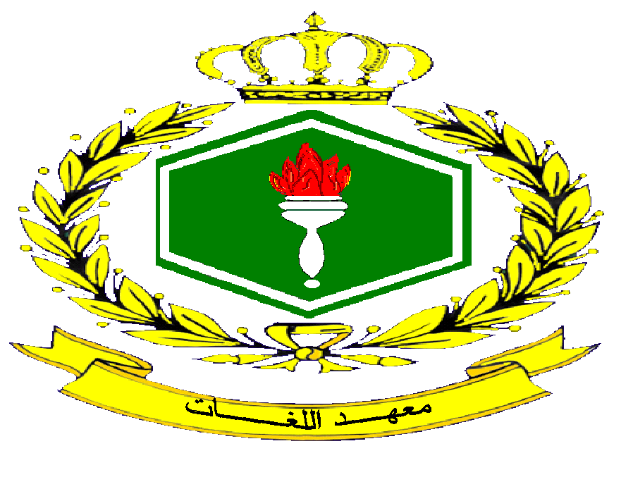
القيادة العامة للقوات المسلحة الأردنية GHQ of Jordan Armed Forces
مديرية العقيدة والتدريب المشترك Directorate of Doctrine and Joint Training
Language Institute
معهد اللغــــــــــــــــــــــــــــــــــــات Zarqa-Jordan
الزرقاء/الأردن Fax No: 962-05390288
فاكس: 962-053902188

LANGUAGE INSTITUTE
1968- 1968
--------------------------------------------------------------------------------------------------
Jordan Armed Forces Language Institute
1. Introduction:
The Jordan Armed Forces Language Institute (JAFLI) is a language training school where (11) languages are being taught simultaneously. It may be considered one of the oldest language centers in the region that teaches various international languages. The institute was founded in 1968 when the first 12-week English language course was held. Depending on qualified staff and adopting a teaching methodology that incorporates between theory and practice through the use of computerized language labs, the Language Institute has managed successfully over more than four decades to execute the assigned duties and has been able to gain a prestigious academic status not only at the national level but also regionally . The institute is located in the city of Az zarqa, 25 kilometers to the north east of Amman.
2. Languages Taught at the Institute. The Institute teaches (10) languages through basic courses that are held regularly for (23) weeks. Some courses are offered at the refresher level besides the basic course (4 weeks-8 weeks) in English, French and German. Other courses are offered at the advanced level (12 weeks) in English and Hebrew. Translation course (English/Arabic is another professional and specialized course that is offered at the English department.
These languages are as follows:
Language | Start date | Participants/per training term | Duration of course | Per year
English | 1968 | 115 | 23 weeks | 2 times
French | 1982 | 15 | 23 | 2 times
Hebrew | 1982 | 30(0fficers and NCOs) | 23 weeks | 2 times
Russian | Suspended (held upon request and demand)
Turkish | 1993 | 15 | 23 weeks | 2 times
German | 1997 | 15 | 23 weeks | 2 times
Italian | 2000 | 15 | 23 weeks | 2 times
Spanish | 2003 | 15 | 23 weeks | 2 times
Chinese | 2009 | 15 | 38 weeks | Once
Arabic for non native speakers | 1993 | Courses are held upon requests from military attaches in different levels vary from basic into intermediate and refresher course | (4 weeks – 18weeks )
3. Number of graduates: The following table shows number of graduates in all languages taught at the institute since the 1st. of Jan 2010 until now.
- English language.
Course | Number of graduates.
English language officers basic course | 150
English language NCOs basic course | 32
English language officers advanced course | 13
Instructor methodology course ( junior teachers) | 14
English language NCOs refresher course (NCOs language qualification) | 75
English language special refresher course for (brigadiers) | 28
(Total) | (310)
- Other Languages.
Course | Number of graduates
French language officer basic course | 21
Hebrew language officers and NCOs basic course | 20
Turkish language officers basic course | 23
German language officers basic course | 16
Italian language officers basic course | 10 ( one course held only)
Spanish language officers basic course | 18
Greek language officers basic course | 9
French language special refresher course for UNMOs | 66 ( 4 weeks )
Chinese language officers basic course | 12
(Total) | (195)
4. Arabic language program for non native speakers.
Arabic language program for non native speakers was launched in 1993.Participants from different countries participate in the Arabic language 3 level program (basic, refresher and intermediate) on regular basis ( UK, Italy, Austria and Turkey).Other participants come to join courses every once in a while and upon requests from military attaches.
The following table shows number of graduates from different country participants since 2000 until now.
No. of participants | country | No. of participants | country
44 | Italy | 205 | UK
20 | Turkey | 10 | USA
2 | Germany | 25 | Austria
4 | Taiwan | 32 | Demark
4 | Azerbaijan | 28 | Romania
2 | Malaysia | 20 | Russia
 |  |  | Total (352)

5.. New material development
(A)Supplementary Material
The supplementary materials –prepared and compiled by staff members-are added to the syllabus to guarantee better understanding of important language issues within the syllabus. They are designed to cover the four skills: reading, writing, listening, and speaking. Some supplementary materials aims to clearly paraphrase some vague grammatical points; others focus on guiding students to use effectively some troublesome and unfamiliar vocabulary whereas some supplementary materials focus on communication and are designed to encourage students and get them to speak throughout simulated - real life situations and communicative based activities. These materials include Grammar, vocabulary, reading, and speaking handouts,
Grammar pamphlets, monthly periodical, English language quizzes and Special curriculum for English refresher courses
6. Special Projects
(A) NCOs English language qualification: The institute has recently embarked on an ambitious 5 year plan to qualify JAF NCOs in English language. The aim of this program is to enhance and foster the presumably substantial role of the NCOs within the JAF and qualify them for better performance when they work overseas.
Participants are subject to an intensive English language course that lasts between six to ten weeks depending on the participants' level and their progress and performance during the course. During this program participants are provided with enough fundamental language knowledge that enables them to interact with their counterparts. The program implies that participants receive further training in the USA where they will be given the chance to serve and co-exist with their American counterparts. To achieve this goal, the syllabus focuses on the following key points and language skills:
(1) Basic English and conversational skills
(2) Military terminology
3) Western cultural awareness)
(4) Basic military writing

(B)Teacher development program
The language Institute in cooperation with Lackland AFB/DLIELC will soon hold a three-week teacher training course during which a Native American teacher from DLI will give lectures on teaching methodologies and mechanism of conducting the OPI. The course will definitely be a priceless chance for our staff members to benefit from the expertise of native teachers so as to enhance their teaching techniques.

( C)Senior Officers Qualification Program
This six-week course is usually held in the afternoon as senior and high-ranking officers are supposedly busy in the morning. The objective of this course is to refresh senior officers’ language skills especially those nominated to attend war and defense colleges abroad and those nominated to assume positions either in military attaches offices or in the United Nations.
(D)Hi-Tech computer labs.
To improve the quality and the outcome of the teaching process, three hi-tech computer labs with the capacity of 90 students were installed lately. These labs provide excellent teaching facilities and enable both teachers and students to benefit effectively from highly sophisticated language software interactive multi-media. They have internet access and connected with TV. channels.
(E)Test Computerization
The institute has started computerizing the English language tests and expected to be completed shortly. The project is viewed as a substantial quantum leap in the assessment process. It will elevate the integrity and the transparency of the tests, and will also keep up the institute updated and compatible with the latest development and modernization in the mechanisms of evaluation and assessment.
7.Points of contact
You may get in contact with the language institute on the following address: JAf HQ, Directorate of Doctrine and Joint Training. Phone number: 0096253902188. Email: jafl.institute@yahoo.com

