**SUMMARY**

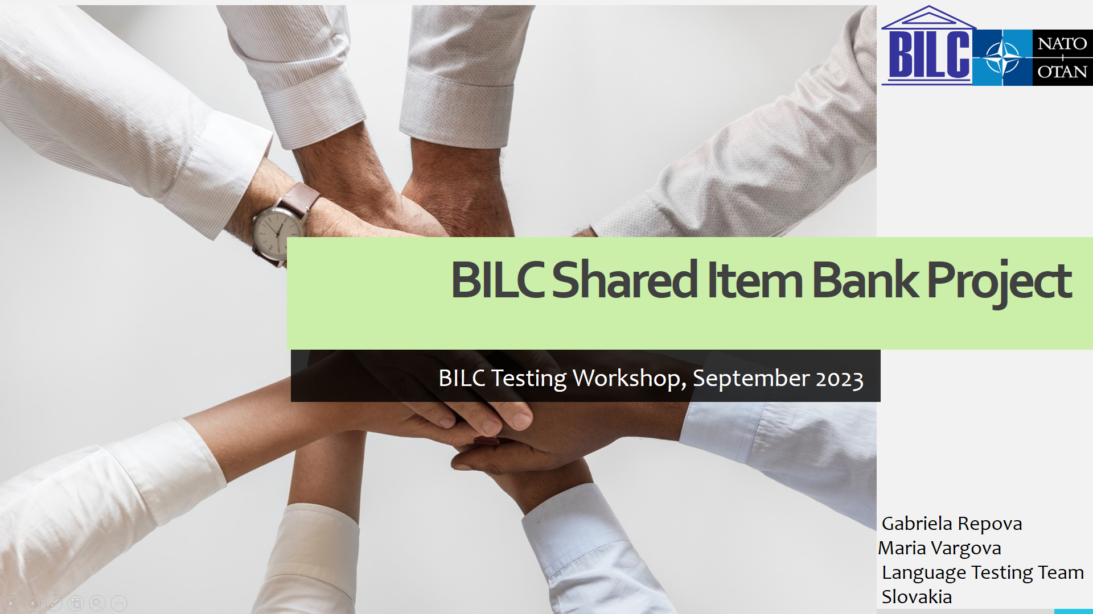

**The presentation provides an update on the progress of the BILC Shared Item Bank project.**

The presentation is in four parts.

Part 1 (Slides 2 – 3) describes the goals of the initiative and lists the WB members.

Part 2 (Slides 4 - 8) informs about the progress being done in case of the reading items

Part 3 (Slides 9) explains what has been done in the area of the listening items design

Part 4 (Slide 10) explains what the next phases of the project are