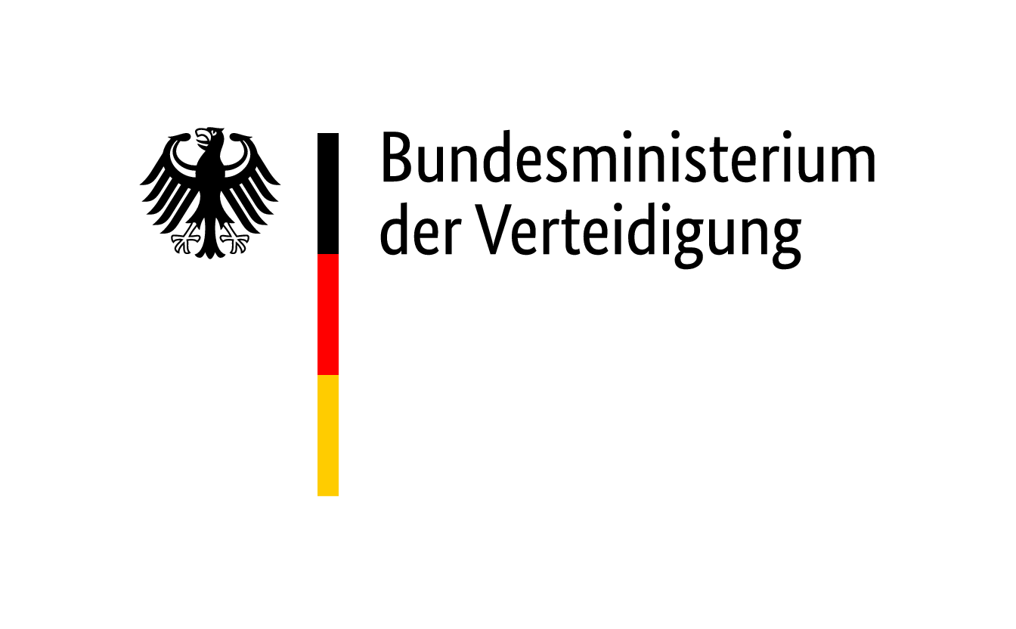

**NATO-BILC Conference 2024**

**Study Group “perpetuated online-teaching”**

(NATO-BILC Konferenz – Arbeitsgruppe Online Unterricht)

**Topic:**

“Beyond the Pandemic – Experiences with perpetuated Online-Teaching at Beginner and Intermediate Level”

**Facilitator:**

Dr. Christoph Loreck, Federal Ministry of Defence, Germany

**Background Information**

Germany contributes to the strengthening of NATO’s defensive capabilities by setting up a brigade in Lithuania. This also results in a need for language courses on site for spouses of the soldiers deployed there.

While the soldiers and civilian personnel will undergo any necessary language training at one of the training facilities of the Federal Office of Languages in Germany, spouses will take classes after having moved to Lithuania. Spouses will mostly be beginners of Lithuanian and at an intermediate level in English. It is intended to offer classes in both languages on a part-time basis, i.e. two to four lessons at 45 minutes per week. The classes will be taught by various external providers.

It is currently assumed that the spouses will be distributed widely across the metropolitan areas of Vilnius and Kaunas. The traffic volume in both cities is fairly high during the day. Altogether, a strong online-based approach seems appropriate in order to avoid frequent to the language training institutions and back.

**Guiding Questions**

In the above context, the general question arises *whether classes for students at beginner and intermediate level can successfully be taught online, entirely*. This question will be discussed by members of the study group, relying on their experiences before, during and particularly after the pandemic.

Experiences during the pandemic are widely documented and numerous guide books as well as scholarly publications focus on teaching online in the era of Corona. Of interest will be, however, whether there are any established online-teaching routines at beginner and intermediate level that predate the pandemic. Yet the more important question is whether there has been any general perpetuation of online-teaching beyond the pandemic or whether training institutions have reverted mostly to classroom-teaching.

**Course of Action**

By comparing the various national approaches and discussing the pros and cons of a strong online-teaching approach at beginner and intermediate level, it should be possible to determine whether this is actually a viable option at the levels described. In turn, this allows for recommendations regarding the particular situation of the spouses.

**Tasks**

1. Introduction Phase:

Please introduce yourself, stating amongst other things which country you are from, what your current job is and whether you have any teaching experience.

1. Preparation Phase:

Sort yourselves into groups of approximately equal size. Select a person to present the groups findings at the end of the discussion phase (this person will also take notes during the discussion phase). Select a time-keeper.

1. Discussion Phase:

What is the general experience with online-teaching in your country / armed forces / language training institution(s)?

Is there a marked difference in the degree of online-teaching at the various language proficiency levels?

Did strong online-teaching routines at beginner and intermediate level exist in your language training institutions before the pandemic?

How did teaching change during the pandemic?

Were online-teaching routines perpetuated into post-pandemic times and to which degree/in which manner?

How do you keep learners engaged during online-lessons?

How do your training institutions support teachers who teach online?

In your opinion, should there be a different teaching approach for soldiers on the one hand and for civilians on the other hand? Does this also concern online-teaching?

In your experience, how much “digital literacy” can you reasonably expect from language learners?

Do neuroscientific learning theories affect the way you teach online?

1. Presentation Phase (selected representative):

Present the findings of your group and recommend a course of action regarding classes for spouses.

1. Final Discussion Round:

How do the findings of each group compare to each other?

________________________________________________________________________

Notes

|  |
| --- |
| 1. What is the general experience with online-teaching in your country / armed forces / language training institution? 2. Is there a marked difference in the proportion of online-teaching at the various language proficiency levels? 3. Did strong online-teaching routines at beginner and intermediate level exist in your language training institutions before the pandemic? 4. How did teaching change during the pandemic? 5. Were online-teaching routines perpetuated into post-pandemic times and to which degree? 6. How do you keep learners engaged during online-lessons? 7. How do your training institutions support teachers who teach online? 8. Should there be a different teaching approach for soldiers on the one hand and for civilians on the other hand? Does this also concern online-teaching? 9. How much “digital literacy” can you reasonably expect from language learners? 10. Do learning theories or maybe even neuroscience affect the way you teach online?   Recommendation: |